Company x data department report

# Exceptive summary:

We exported the sales data from our database, and we conducted some analysis on it to gain insights into some of our sales operations and study ways of enhancing our services based on a certain scope

## Scope

* Customer Loyalty
* Strengths and weak points
* Performance
* Customer Experience

## Data Specs

Here are the Tables we used to conduct analysis:

* Order
* Return
* Shipping cost
* People

# The Analysis:

## Customer Loyalty:

* What is the Most Used Ship mode by our customers?

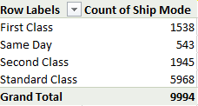

Based on the Table above we counted the number of times each shipping mode occurred in the orders table.

And we found **that the Standard Class Shipping Mode** was the most one used by Our Customers by **72.97%.**

Recommendations:

1. We should focus more promotions on the standard shipping Mode as it is the most used.
2. We should find ways to reduce the cost of the standard shipping mode and make sure it's profitable as it is the most used shipping mode.
3. First Class Shipping mode was the least used shipping mode which might be better to revise the cost and the possible scenarios where it might be removed

* Who are our top 10 customers in terms of sales and order frequency?

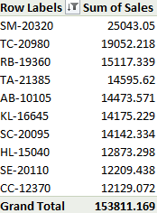

These 10 customers account for a significant portion of total sales. They represent your **high-value customers** and likely frequent buyers.

Recommendations:

1. **Customer Retention Programs:**
   1. Develop loyalty programs with discounts or points systems targeted at these customers to maintain their purchasing levels.
   2. Create exclusive offers or early access to new products.
2. **Personalized Marketing:**
   1. Use their purchase history to recommend related or high-margin products.
   2. Send customized emails and promotions to maintain engagement.
3. **Improve Customer Experience:**
   1. Offer dedicated account managers for these high-value customers.
   2. Conduct surveys to understand their satisfaction levels and areas of improvement.
4. **Upselling and Cross-Selling:**
5. Identify complementary products or services for upselling.
6. Provide bundle offers tailored to their preferences.
7. **Reward Top Customer:**

**-**Acknowledge their contribution with exclusive perks, such as:

* + 1. Free shipping for a period.
    2. Invitations to premium customer events or webinars.
* Also we want to know our top 10 customers in terms of order frequency?

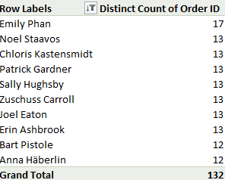

**Emily Phan** leads with 17 orders, significantly higher than the others in the top 10.

Eight customers have 13 orders each, indicating a consistent level of engagement.

The lowest frequency among the top 10 is 12 orders, by **Bart Pistole** and **Anna Häberlin**.

**Recommendations**:

1. **Reward Loyalty**:
   1. **High-frequency customers (13+ orders)**:
      * Introduce a loyalty program offering rewards or discounts for milestones like 15 or 20 orders.
      * Example: “10% off on your 15th order.”
2. **Personalized Engagement**:
   1. For customers like **Emily Phan**:
      * Send a personalized thank-you message or offer exclusive benefits, such as early access to new products.
      * Provide a small gift or coupon to reinforce loyalty.
3. **Encourage More Frequent Orders**:
   1. **Moderate buyers (12 orders)**:
      * Offer time-sensitive incentives like, "Order within the next week to receive 15% off."
      * Highlight popular products or seasonal deals through email campaigns.
4. **Upsell and Cross-Sell Opportunities**:
   1. Use customer purchase history to recommend complementary or related products.
   2. Example: “Based on your recent purchase, you might like [Product X].”
5. **Enhance Reordering Convenience**:
   1. Implement a "Reorder Now" feature to make frequent purchases easier.
   2. Provide subscription options for commonly reordered products.
6. **Customer Feedback**:
   1. Conduct a survey with these top customers to understand their preferences and areas where service can improve.

## Strengths and weak points:

* Which segment of clients generates the most sales by Category?

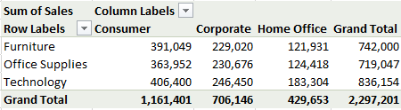

**Technology** is the **highest-selling category** with a total of **836,154** in sales.

Within Technology, the **Consumer segment** leads with **406,400** in sales, making it the most profitable combination.

**Recommendations**:

1. **Focus on Technology Products for the Consumer Segment**:
   1. Prioritize marketing campaigns targeting consumers with promotions on popular technology products.
   2. Offer bundled deals or discounts for high-demand items.
2. **Expand Consumer Reach**:
   1. Use targeted ads and email campaigns to reach new consumer customers interested in technology.
   2. Highlight ease of use, affordability, and quality to appeal to the consumer market.
3. **Enhance Product Variety and Availability**:
   1. Expand the technology product range to include innovative and trending items.
   2. Ensure sufficient stock to meet demand in the consumer segment.
4. **Boost Sales in Other Segments**:
   1. Analyze preferences in the **Corporate** and **Home Office** segments to create tailored offers for technology products.
5. **Seasonal Campaigns**:
   1. Plan sales during peak shopping periods (e.g., holidays or back-to-school) to maximize revenue from the Consumer segment.

* Which city has the most sales value?

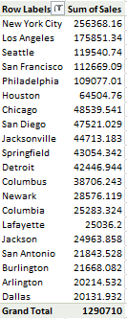

**New York City** is the top city with sales of **256,368.16**, contributing the most to overall sales.

**The top 5 cities** (New York City, Los Angeles, Seattle, San Francisco, and Philadelphia) collectively generate over **773,506**, which is **60%** of the total sales in the top 20 cities.

Cities like Houston, Chicago, and San Diego are mid-performers, presenting potential for growth.

**Recommendations**:

1. **Focus Marketing in High-Sales Cities**:
   1. Keep boosting sales in **New York City** and **Los Angeles** with special deals.
2. **Grow in Mid-Level Cities**:
   1. Increase visibility in **Houston**, **Chicago**, and **San Diego** through promotions or events.
3. **Boost Sales in Lower Performing Cities**:
   1. Offer discounts or incentives in **Dallas** and **Arlington** to drive more sales.
4. **Stock Popular Products in Key Cities**:
   1. Make sure to have enough inventory in top cities like **New York City** and **Seattle**.

* Which state generates the most sales value PERCENTAGE BY REGION?

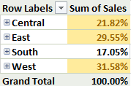

The **West region** generates the highest sales with **31.58%** of total sales, followed closely by the **East region** with **29.55%**.

**Recommendations**:

1. **Focus on High-Performing Regions**:
   1. **West and East**: Continue strengthening marketing efforts in these regions, offering promotions and loyalty programs to maintain high sales.
2. **Increase Focus on the South and Central Regions**:
   1. **South and Central**: Develop targeted campaigns and special offers to boost sales in these regions.
3. **Product Stocking and Distribution**:
   1. Ensure that popular products are well-stocked in high-performing regions (**West** and **East**) to avoid stockouts and maximize sales.

## Performance

* What are the top performing product categories in terms of sales and profit?

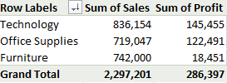

**Technology** is the top-performing category both in terms of sales (**836,154**) and profit (**145,455**).

**Furniture** has strong sales (**742,000**) but low profit (**18,451**), suggesting that although it sells well, the profit margins are low.

**Office Supplies** ranks between **Technology** and **Furniture** in both sales and profit.

**Recommendations**:

1. **Focus on Technology**:
   1. Since **Technology** is the leading category in both sales and profit, consider increasing marketing efforts and stock levels for high-performing products in this category.
2. **Improve Profitability in Furniture**:
   1. Investigate why **Furniture** has strong sales but lower profit. It could be due to high costs or low margins. Consider adjusting pricing or reducing operational costs to increase profitability.
3. **Leverage Office Supplies**:
   1. With **Office Supplies** being a solid performer in both sales and profit, explore ways to further optimize its performance, such as introducing more value-added products or improving customer retention.

* What is the most profitable product that we sell?

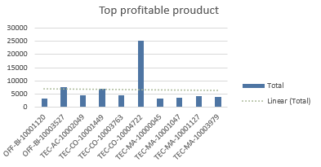

**TEC-PH-10004977** is the highest profit-generating product with a profit of **838.84**.

Some products have negative profits, such as **FUR-BO-10000780** (-767.74) and **FUR-BO-10000468** (-133.11).

Recommendations:

1. **Focus on High-Profit Products**:
   1. Prioritize marketing and inventory for products like **TEC-PH-10004977**, **TEC-PH-10004908**, and **FUR-BO-10000362**.
2. **Evaluate Loss-Making Products**:
   1. Investigate products with negative profits (e.g., **FUR-BO-10000780** and **FUR-BO-10000468**) and consider discounting, returning, or improving their profitability.
3. **Product Portfolio Adjustment**:
   1. Review the pricing and cost structure for products with low or negative profits to optimize profit margins.

## Customer Experience

* On Average how long does it take the orders to reach our clients based on ship mode?

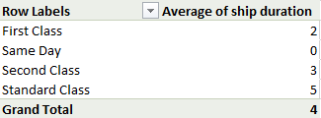

**Same Day** delivery is the fastest with an average of **0 days**.

**Standard Class** takes the longest with an average of **5 days**.

The overall average shipping duration is **4 days**.

**Recommendations**:

1. **Promote Faster Delivery Options**:
   1. Highlight **Same Day** and **First Class** delivery options to attract time-sensitive customers.
2. **Optimize Standard Class Delivery**:
   1. Reduce shipping times for **Standard Class** by improving logistics and partnerships with carriers.
3. **Customer Communication**:
   1. Clearly communicate delivery times for each class to manage customer expectations and satisfaction.